**How To Organise/ Develop A Simulation Course**

**STEP 1: Organising A Course**

**Step 2 : Course Proposal Form**

**Please Click on the link below or Scan the QR Code to complete the details on the form, once submitted the form will automatically be sent to the Simulation Centre Team to Action.**

[**https://forms.office.com/e/Mt8mhP4kuv**](https://forms.office.com/e/Mt8mhP4kuv)

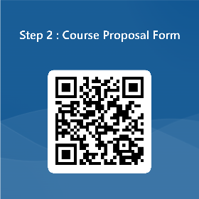

**Thank you for your enquiry. The Simulation Centre Team will be in touch.**